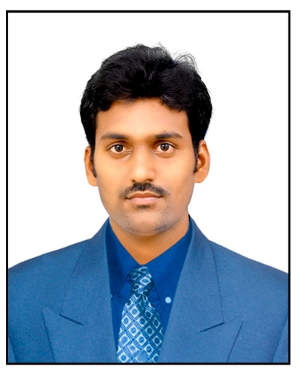

**SANTHA RAO JINAGA**

**Key Skills**

Basics of Java

Auto Cad

Mat Lab

**Profile Summary**

Python

B-Tech in Mechanical Engineering with a CGPA of 7.0 along with some basic core java skills Trained by bit Labs, like to take initiative and seek out new challenges in the IT sector.

HTML5

Microsoft Office

**Projects**

**Title: Concentration Solar Thermoelectric Generator**

**Description:** Photovoltaic is one method of converting solar light in electricity and companied with thermal system will producing heat and electricity at the same time. This energy used to produce Electricity That can used for irrigation purpose.

**Technologies**: Photovoltaic Technology and Thermoelectric Technology.

**Title: Mini Wood Turning Lathe Machine**

**Description:** Woodturning is the craft of using a wood lathe with hand-held tools to cut a shape that is symmetrical around the axis of rotation

**Technologies:** Apron mechanism

**Contact:**



+91 9505567373

[santharao6001@gmail.com](mailto:santharao6001@gmail.com)

[LinkedIn- Santharao](https://www.linkedin.com/in/santharao-jinaga-44a113235/)

bitLabs Associate Full-Stack Developer program

**Certifications**

**B-Tech: Mechanical with 7.0 CGPA - 2021**

Sri Venkateswara College of Engineering and Technology, Srikakulam.

**DIPLOMA: Mechanical with 64.53 % - 2017**

Aditya Institute of Technology and Management, Tekkali.

**SSC with 7.0 CGPA – 2014**

Sri Chaitanya Techno School, Palasa.

**Education**

* Telugu
* English

**Languages Known**

**Achievements:**

* Won first place in “Quiz”

Competition at the school level.

* Attended Hybrid Vehicle workshop.

**Interests:**

* Following to develop Interpersonal skills
* Cooking, Traveling.
* Marketing

[GitHub-Santharao](https://github.com/santharao6001/Java_Practice)

